2312 N Rosemont Blvd #103
Tucson AZ 85712
Ph: (520)886-8800
Fax: (520)886-8805
www.azvisiontherapy.com
visiontherapy@live.com

Referral To: Amy Thomas, OD, FCOVD or Haley Penrod, OD
Developmental / Neurocognitive Optometrists

Patient
Name:________________________________
Parent/Guardian Name: __________________
Best Phone: ___________________________

Referring Doctor
Name:________________________________
Phone: _______________________________
Fax:__________________________________

Reason for Referral
Convergence Insufficiency
Binocular Dysfunction
Accommodative Dysfunction
Oculomotor Dysfunction
Amblyopia
Strabismus
Learning Related Difficulties
Sports Vision Evaluation
Traumatic Brain Injury Rehabilitation
Stroke Rehabilitation
Other:_________________________

Patient Rx
OD __________________________ 20 / ______
OS __________________________ 20 / ______

Referring doctor will provide the frames and:
Prefers to provide lenses (and also the 3-4 remakes that may be necessary)
Prefers to allow AVTC to provide the lenses (including the 3-4 remakes that may be necessary)

Patient Ocular Health
Normal with dilation
Normal without dilation
Pathology was found and is being followed by the appropriate provider
NOTE: Please bring this form with you to our office to receive a $50.00 credit toward the Visual Skills Exam Evaluation

Is There a Vision Problem?
Assign a value for each symptom
0=Never / 1= Rarely / 2=Sometimes / 3=Frequently / 4=Always
Blurred vision at near or far
Double vision
Headaches with near work
Words run together when reading
Burning, stinging, watery eyes
Falls asleep when reading
Vision worsens at the end of the day
Skips or repeats lines when reading
Dizziness or nausea with near work
Head tilt or closing one eye when reading
Difficulty copying from the chalkboard
Avoidance of reading and near work
Omits small words when reading
Writes uphill or downhill
Mis-aligns digits in columns of numbers
Reading comprehension declines over time
Inconsistent/poor sports performance
Holds reading material too close
Short attention span
Difficulty completing assignments in reasonable time
Says "I can't" before trying
Avoids sports and games
Difficulty with hand tools such as scissors, calculator, keys, etc.
Inability to estimate distances accurately
Tendency to knock things over on desk or table
Difficulty with time management
Difficulty with money concepts such as making change
Misplaces or loses papers, objects, or belongings
Car sickness/motion sickness
Forgetful, poor memory
Add the scores together:
20-24 points = Vision problems suspected
25 points or above = High likelihood of vision problems

Regarding your referral to Arizona Vision Therapy Center…

Most patients referred to us are surprised to learn that there may be underlying issues with their vision. Your recent eye exam indicated a visual or perceptual problem that requires more in-depth testing.

You would be amazed at how common vision problems are. Studies show that about one in four people have some sort of visual limitation that affects their school, work and personal life. Our office focuses on identifying and remediating those problems.

What Happens Next?

Please contact our office for preliminary information on vision therapy, and to discuss your doctor’s findings. We can work with you to determine whether a full examination at our office is your best option. If so, your first appointment, the Visual Skills Evaluation, will test eighteen different visual skills to assess the extent of the visual problems and possible treatment plans.

If the doctor feels that further testing is called for, we will schedule you for a Perceptual Skills Evaluation. Following that, the doctor will prepare a report with your diagnoses and an explanation of how these vision problems tend to affect daily life. At which time, the doctor will discuss their findings with you and what your best treatment options are.

You can aid this process by filling in the checklist on the front of this form which will help to give you a better understanding of your current situation. The higher the score, the more likely it is that a visual problem exists. Dr. Thomas will use this information as part of her evaluation.

What is Vision Therapy?

Vision therapy utilizes the plasticity of the brain and the ability the brain has to rewire itself. Treatment consists of a series of sessions with a trained therapist, who guides patients through the process of learning or relearning how to use the visual system.

This therapy helps patients understand how to use their vision most effectively. Treatment time varies according to the nature of the problem.

How Can I Learn More?

Please call with any questions or attend one of our free webinars about how vision can affect school attention, work and even trigger changes in behavior. You can visit the web sites below:

www.covd.org www.oepf.org

www.visionhelp.com www.pavevision.org

You can also ask questions on the Facebook page “Vision Therapy Parents Unite”

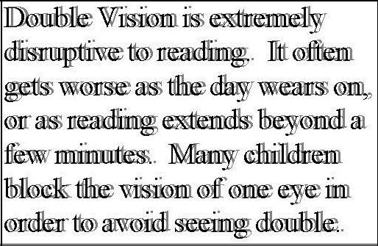

Here is an example of a common treatable vision problem. Many children don’t realize they are seeing double because they’ve always seen that way.

It is a good idea to show this to the child while asking if the words on the page ever look like this. Also ask if the words seem to swim or move on the page, especially later in the day when the child is fatigued. A yes is a clear sign of a vision problem. If the answer is no, there may still be a vision problem if the child may be shutting off one eye to avoid the double vision.

